Proposition for IO5
- The idea of this IO5 is to have some questions/ sentences that lead the users to reflect on the way how to approach the students/the way how to teach.
- The doesn’t mean that the optional-answers are correct or wrong, but will just direct how the “game” keeps going. If the user selects an answer “ “, on the surface will appear an !warning! where the user will be lead to think on the other options instead of keep going with that one.

- Every box(or conjunct of options) appear on the surface, when users click on an option, if is a (green one here) will automatically lead to the next options, if is red, the warning appears and the previous options are showed again
You are a teaching/trainer, your boss asked you to train/teach in a different country where you never been and I don’t know yet where it will be. You are now wondering in front of your empty suitcase: What should I take??
Going to teach in a different country where I never been. Surprise What should I take?

warning1
Will improvise !
Teaching books
Powerpoint slides
Will search about cultural differences, new ways to teach in foreign language…

w2
I’m aware of the differences but I have my way to teach. Will try to generalize and teach according to it
Will wait for the apresentation of the students manage the first classes according to the student’s expectations, fears and skills.
Will manage the classes according to my daily-mood
warning3
I feel that it’s working! But how to be sure that they are learning?
The students like my classes and are engaged to it but I feel that they don’t take the class too serious.
I’ve got some ideas for my classes. With some music, storytelling, and some games I can teach too.
It’s time to some theoretical approach now.
Is good to know about the students, but I think that personal experiences are not so relevant for my class
Will start building my classes according to the information about the students

warning4
5 warning

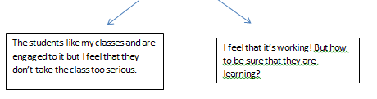

Will wait to see the exam’s grades.
Will make some reflection moments so I can have an idea of the progress of my students.
Evaluation maters

