I-Motole IO3 - Relationship Skills with Others – Inspira Plus

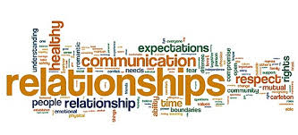

What are Relationship Skills?

Relationship Skills are the reciprocal social and emotional interaction between two or more individuals in an environment. All Relationship skills are deeply rooted in answering our own and other people’s Emotional Needs.

How we behave towards others, and in turn, how others behave towards us is largely a reflection of our own and others’ emotional needs.

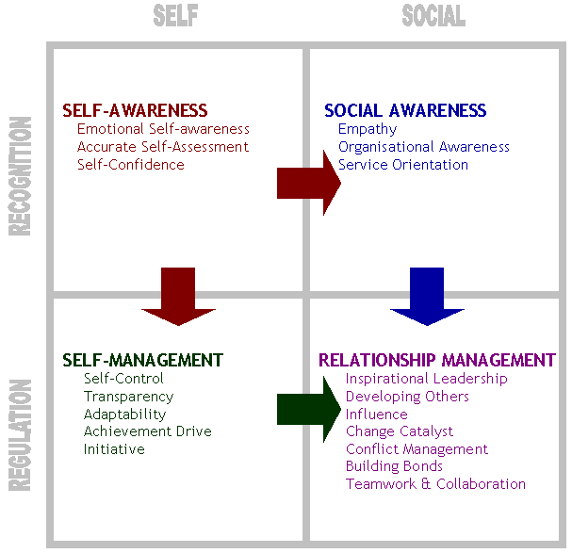
Exercise 1: Circle the 10 most important emotional needs for you:
accepted  acknowledged  admired  appreciated  approved of  authentic  believed in  capable  cared about  challenged  clear (not confused)  competent  confident  forgiven  forgiving | free  fulfilled  heard  helped  helpful  important  in control  included  listened to  loved  needed  noticed  powerful | private  productive / useful  reassured  recognized  respected  safe / secure  supported  treated fairly  trusted  understanding  understood  valued  worthy
Exercise 2: Rate your relationship skills with others:

1 | Very poor
2 | Poor
3 | Somewhat good
4 | Good
5 | Very good

1. | Making an introduction | 1 | 2 | 3 | 4 | 5
2. | Listening to what people say | 1 | 2 | 3 | 4 | 5
3. | Showing interest in what people say | 1 | 2 | 3 | 4 | 5
4. | Communicating my feelings | 1 | 2 | 3 | 4 | 5
5. | Responding to anger/hostility | 1 | 2 | 3 | 4 | 5
6. | Responding to praise from other people | 1 | 2 | 3 | 4 | 5
7. | Responding to expression of anxiety from other people | 1 | 2 | 3 | 4 | 5
8. | Responding to negative feedback from other people | 1 | 2 | 3 | 4 | 5
9. | Responding to no feedback from other people | 1 | 2 | 3 | 4 | 5
10. | Reading other people's feelings | 1 | 2 | 3 | 4 | 5
11. | Giving information about myself | 1 | 2 | 3 | 4 | 5
12. | Advising on emotional issues/difficulties | 1 | 2 | 3 | 4 | 5
13. | Waiting for replies | 1 | 2 | 3 | 4 | 5
14. | Expressing support | 1 | 2 | 3 | 4 | 5
15. | Summarising information | 1 | 2 | 3 | 4 | 5
16. | Being able to keep other people’s interest and attention | 1 | 2 | 3 | 4 | 5
17. | Connecting with other people | 1 | 2 | 3 | 4 | 5
18. | Resolving conflicts | 1 | 2 | 3 | 4 | 5
Now, based on the list of Emotional Needs in Exercise 2, please explain which emotional needs of yours are currently being met: .……………………………………………………………………………………………………………………………………………………….………………………………………………………………………………………………………………………………………………
……….…………………………………………………………………………………………

Based on the list of Emotional Needs in Exercise 1, please explain which emotional needs of yours are currently not being met: .……………………………………………………………………………………………………………………………………………………….………………………………………………………………………………………………………………………………………………
……….…………………………………………………………………………………………

Now, based on the answers you gave in Exercise 2, describe how you relate to others currently. Make sure to describe which relationship skills you are Good at, and which ones you believe you can improve:

I am good at: .……………………………………………………………………………………………………………………………………………………….………………………………………………………………………………………………………………………………………………
……….…………………………………………………………………………………………

I need to improve: ……….…………………………………………………………………………………………
.……………………………………………………………………………………………………………………………………………………….………………………………………………………………………………………………………………………………………………

Now, based on the answers you gave on this page, write a brief self-assessment paragraph focusing on what emotional needs are important to you, and why they affect how you behave with other people, and how other people behave with you:

……….…………………………………………………………………………………………
.……………………………………………………………………………………………………………………………………………………….………………………………………………………………………………………………………………………………………………
……….…………………………………………………………………………………………
.……………………………………………………………………………………………………………………………………………………….………………………………………………………………………………………………………………………………………………

