IO3 interactive tool

- In one side of the pagethere is an empty trianguel with a different levels (the base is the “number one”). // On the other, different needs/ concepts
Possibility to choose where to live
- Ask to the users to drag their needs in order of their priorities in life/ the first that need to be satisfied (on the base) till the top.
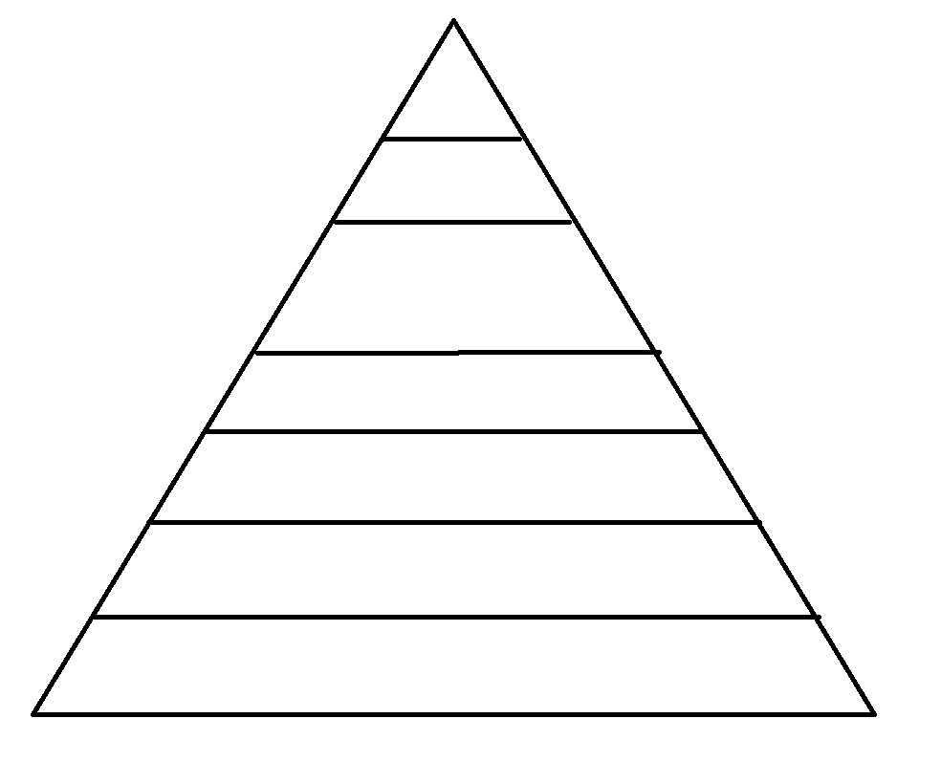
spirituality
Freedom to move and to talk
hobbies
peace
work
Time for personal life
health
autonomy
love
money

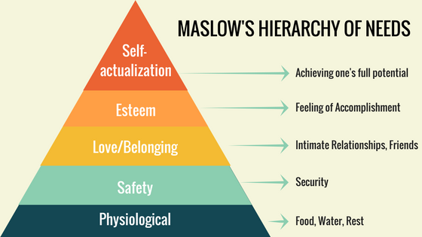
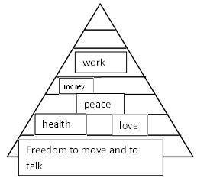
- After validate, the piramid completed by the users reaper side by side with maslow pyramid and a brev explanation of the theory and asking the users to comparate and reflect about it.

- Think that also can had a link “know more about it” peut-etre: https://blog.cognifit.com/maslows-pyramid/

- “Next page”: “- Now that you are more aware of your needs priorities, will be easy to organize your future goals and projects. But first…. Is also important to be know about you.
On this stage, write it down 4 areas that you like and 4 areas that you don’t!”

1)
2)
3)
4)

1)
2)
3)
4)

- If there is the possibility to the system “identify” the words and on the next phase create links with “inspirational” projects and websites. / I can find them for each big theme such: ecology/environment , culture , arts , animals, law ,work , psychology , philophy …. Etc…

Time to think in your goals! Create your Reality check to help you to pursuit it

Written Support for Maslow:
Maslow first introduced his concept of a hierarchy of needs in his 1943 paper "A Theory of Human Motivation" and his subsequent book Motivation and Personality. This hierarchy suggests that people are motivated to fulfill basic needs before moving on to other, more advanced needs.
While some of the existing schools of thought at the time (such as psychoanalysis and behaviorism) tended to focus on problematic behaviors, Maslow was much more interested in learning about what makes people happy and the things that they do to achieve that aim.
As a humanist, Maslow believed that people have an inborn desire to be self-actualized, that is, to be all they can be. In order to achieve these ultimate goals, however, a number of more basic needs must be met such as the need for food, safety, love, and self-esteem.
There are five different levels of Maslow’s hierarchy of needs. Let's take a closer look at Maslow’s needs starting at the lowest level, which are known as physiological needs.
Regarding human needs, one of the most important contributions to psychology is the so-called Maslow pyramid. In it, the author ordered human needs in a hierarchy.
In order to be able to go up steps, it is necessary to satisfy the needs in the previous steps. Our progress will depend on our own actions, on the active attitude we adopt to keep moving forward. How? Through motivation.
The first three steps of the pyramid are “deficiency needs” (D-needs), which are the first three steps of the pyramid, and “being needs” (B-needs), corresponding to the top two steps of the pyramid. Without meeting the needs of each step, one cannot climb to another step. Only successful and motivated people can reach self-actualization which, whether conscious of it or not, is every human being’s goal.

Human behavior can be altered if different needs are not met. The lower the step to be satisfied, the more it affects behavior.
Maslow is considered one of the founding fathers of humanistic psychology. This type of psychology explores issues from a philosophical perspective of life in order to answer meaningful questions. It differs greatly from other psychological perspectives, especially behavioral psychology, which only focuses on observable stimuli (like behavior), or from psychoanalysis which focuses on the unconscious.
Maslow believed human needs could be ordered, therefore he created a hierarchy, and with that, a pyramid. Maslow’s pyramid has five levels, the highest level being self-actualization. The way to climb to the top, according to Maslow, is to have an active attitude. Until our basic needs are not met, we can’t climb the next step. We are all responsible for our own progress. Motivation is the key to progressing and moving up.

