1. Identify the most important dimensions in your life (love, family, money, friends, spirituality, time for me, work, sports, …..)
2. Classify them from 1 to 4 and write them in each section of the wheel .
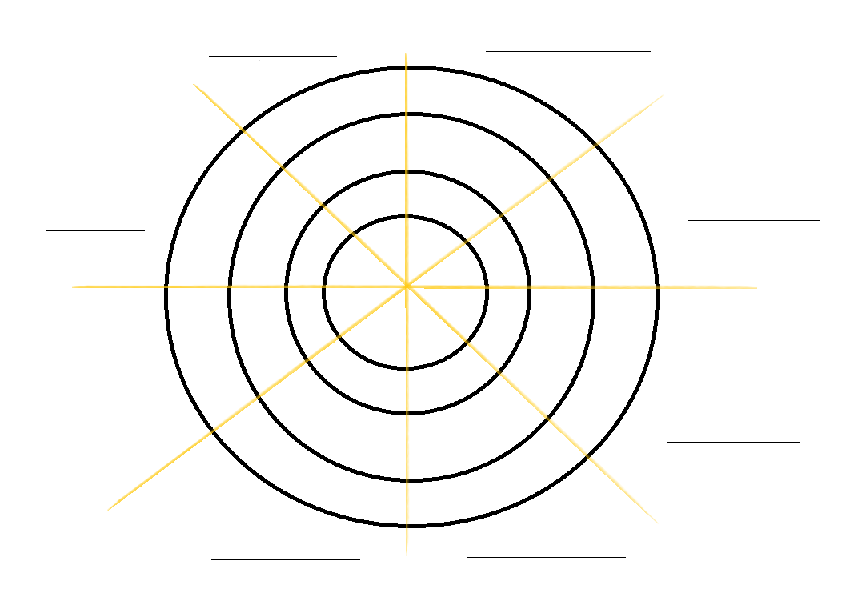
3. Color the part of the wheel corresponding to the domain of your life in accordance with the classification that you gave before. One is the center of the wheel – How much you have of each domain in your life?
4. Observe… What you would like to keep? And to change? What will you do for it?
5. Make a list for each domain and write what you would like to have more from each and with possible actions to achieve it

