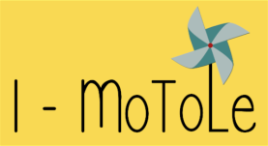
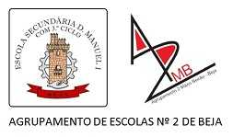
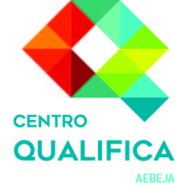
Project No. 2017-1-FR01-KA204-037385

IO5 - INTERACTIVE TOOL
Quizz on “Using portfolios as a motivational tool in adult education – an autobiographical approach
A Set of 8 statements, correct or incorrect, with further explanation (pop-up)

Statement | Correct | Incorrect | Further explanation
1 The concept of portfolio was inherited from arts. | X |  | The portfolio was originally used in arts to display the artist’s work and assess artistic skills.
2 The portfolio is a full collection of the work done and evidence gathered during a period of time. |  | X | The portfolio is a chosen collection of the work and evidence that best portrays someone’s performance, competences and knowledge
3 Portfolios are more adapted to professional purposes rather than educational uses. |  | X | Portfolios are more and more used in education and can be adapted to different contexts and ages.
4 Relevance and structure are keywords on a portfolio. | X |  | Portfolios are a structured collection of the most relevant pieces of work and evidence of learnings and competences.
5 Portfolios are more focused on outcomes. |  | X | Portfolios portray the process, rather than just the outcomes.
6 Personal reflection upon performance and achievements should be a part of the portfolio | X |  | Focusing on the (learning) process, a portfolio should always be reflective.
7 A portfolio has a material support. |  | X | Portfolios can have different formats (a physical support, digital or both digital and material)
8 Competences acquired throughout life are not relevant for an educational portfolio. |  | X | Personal and social competences are cross-sectional and the basis for other competences such as professional and educational.

Note: The “further explanation” part is supposed to open in a pop-up manner for every answer.

B Set of 2 matching exercises

1 Associate the following concepts with the corresponding definitions.

1 Specific aims | A Detailed objectives that clarify the initial goals.
2 Evidence | B Pieces of work, text, photos, and other documents.
3 Overall aims/standards | C The goals needed to be achieved.
4 Assessment criteria | D A set of principles or standards on how to evaluate.
5 Contents and/or topics | E The issues to be approached.

2 Associate the following proposed parts of a portfolio with its contents.
1 My photography | A Description of physical features and character.
2 My life should be a book | B Relevant childhood and adolescence memories.
3 The others and me | C A portray of one’s social network of friends and peers.
4 My achievements | D Self-assessment of acquired skills and competences, informal, non-formal and formal learnings.
5 My projects | E Planning of future goals.

C Set of 8 statements to fill in the gaps

1 Fill in the gaps with a suitable word. The first two letters are provided.
- Building a portfolio is an on_______ process.
- Building a portfolio is to be sh___________ by the trainer and the learner.
- The documents integrating a portfolio should be re___________.
- These documents represent the ev___________ to be assessed.
- The trainer should in____________ its learners with creative and relevant activities.
- The or_____________ of the portfolio should show progress and acquired competences.
- The progress made should always be monitored through re____________.
- The portfolio should be an op ____ tool that can always be changed and updated throughout life.

SOLUTIONS
- ongoing
- shared
- relevant
- evidence
- inspire
- organisation
- reflection
- open

D Free text exercise

1 When designing a course and planning a portfolio, the first step is about defining standards and contents.
Imagine a citizenship course on rights and duties. Decide on the contents related to the proposed aims.
Topic | Aims | Contents
Freedom and citizenship | - Acknowledges the responsibility inherent to individual freedom and democracy.  - Assumes labour rights and duties as an active citizen.  - Identifies the fundamental rights within a democratic modern state.  - Participates, consciously and sustainably, in the global community. | - ________________________________________  - ________________________________________  - _________________________________________  - _________________________________________

POSSIBLE ANSWERS
- The concept of freedom and civil rights.
- Labour rights.
- The active citizen’s role in a democratic community
- Global issues

E Survey

1 Have you ever built or used a portfolio?

- Yes
- No

2 If no explain why not
- I had never heard about it
- I did not see the point
- I did not know how to use it
- Other reasons

3 If yes explain in what situation(s)
- For personal record
- For educational purposes
- For professional purposes
- Other situation

F Survey to assess the quiz

1 Assess this quiz on a scale of 1 to 5 .
1 Relevance | 1 | 2 | 3 | 4 | 5
2 Information | 1 | 2 | 3 | 4 | 5
3 Coherence | 1 | 2 | 3 | 4 | 5
4 Type of exercises and length | 1 | 2 | 3 | 4 | 5

2 Feel free to share any comments.

Thank you for your cooperation and interest.

