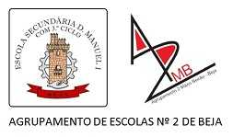
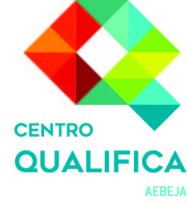
Project No. 2017-1-FR01-KA204-037385

IO3/IO5 - INTERACTIVE TOOL
Quizz on “Evaluating the portfolio”
A Multiple choice exercise

Read the text attentively
The volunteering has had a positive effect on my life. I volunteered as a listener. Listeners are inmates that are trained to listen to other inmates when they are in need of someone to talk to. Sometimes it would be something like they miss their girlfriend or their kids, other times it was along the lines of wanting to kill themselves. Sometimes it was trivial, other times it was horrifying.
For the first time in my life I felt like I had a responsibility and I took it seriously.
Through this I learnt a lot about people and also about myself. I learned how to empathise and I have found this to be beneficial in many ways in my personal and working life. Being a listener involved being a part of a close-knit team.
Through volunteering I gained leadership qualities, compassion, and I learnt about the importance of being reliable.
Jonathan Watts, chef and restaurant owner, winner of the DofE award, June 2019

Match the evidences from the text with the suitable competence demonstrated.

COMPETENCES/ OUTCOMES | EVIDENCE
1 Making decisions | A I volunteered as a listener.
2 Listening objectively | B Listeners are inmates that are trained to listen to other inmates when they are in need of someone to talk to.
3 Understanding the failings of others | C Sometimes it would be something like they miss their girlfriend or their kids, other times it was along the lines of wanting to kill themselves. Sometimes it was trivial, other times it was horrifying.
4 Working with people | D Being a listener involved being a part of a close-knit team.
5 Maintaining a positive attitude | E I learned how to empathise and I have found this to be beneficial in many ways in my personal and working life.

Support information (should be accessible/visible to do the exercise)

B Multiple choice

Read and reflect upon the level of accomplishment that the following statements demonstrate. Choose the suitable option.

EVIDENCE | I can…
1 I had heard about volunteering but did not care. | a. identify it but did not develop it. (right answer)  b. understand it and learned about it but did not put into practice.  c. do it and learned how to.
2 Through volunteering I gained leadership qualities. | a. identify it but did not develop it.  b. understand it and learned about it but did not put into practice.  c. do it and learned how to (right answer)
3 I ended up organising a group of volunteers and we attended regular meetings and supporting sessions. | a. identify but did not develop it.  b. understand it and learned about it but did not put into practice.  c. do it and learned how to (right answer)
4 We were trained by other volunteers to become an informed listener. | a. identify but did not develop it.  b. understand and learned about it but did not put into practice. (right answer)  c. do it and learned how to

C Survey

1 Will you use a portfolio?

- Yes
- No

2 If no, explain why not
- It is difficult to use
- I do not see the point
- I do not know how to use it
- Other reasons. Explain.

3 If yes, explain in what situation(s)
- For personal record
- For educational purposes
- For professional purposes
- Other situation. Explain.

D Survey to assess the quiz

1 Assess this quiz on a scale of 1 to 5 .
1 Relevance | 1 | 2 | 3 | 4 | 5
2 Information | 1 | 2 | 3 | 4 | 5
3 Coherence | 1 | 2 | 3 | 4 | 5
4 Type of exercises and length | 1 | 2 | 3 | 4 | 5

2 Feel free to share any comments.

Thank you for your cooperation and interest.

